**AI ENABLED INTEGRATED APPLICATION FOR LUGGAGE**

**CAREER SYSTEM**

|  |  |  |  |
| --- | --- | --- | --- |
| Atish Gorka  *Department of IT*  Ajay Kumar Garg Engineering College  Ghaziabad, India | Gaurav Singh  *Department of IT*  Ajay Kumar Garg Engineering College  Ghaziabad, India | Kartikey Tyagi *Department of IT*  Ajay Kumar Garg Engineering College  Ghaziabad, India | Sahastranshu Mishra *Department of IT*  Ajay Kumar Garg Engineering College  Ghaziabad, India |

**Abstract**

The importance of a luggage carrier system in today's era lies in its ability to address the challenges posed by increased travel, globalization, security concerns, and technological advancements. By providing efficient, secure, and data-driven solutions, these systems play a crucial role in shaping the future of the transportation and logistics industry. This project implements, AI integrated services into the logistic management application to enables the tasks such as parcel similarity detection, travel time detection, upcoming hubs tracking and the destination suitability prediction for safe travel of the upcoming hubs. If there is a lack of possibility found then the good route will be suggested to reach the next hub. Also integrated GPS services in order to identify the present location and routes. The luggage’s location will be traced when transporting one hub to another and if the luggage’s location getting changed more than a particular range then the notification will be sent to the previous and oncoming hub managers and the map will be created for the luggage present location. Upon the luggage reaching the next hub, the system will generate goods receiving notes. Subsequently, a comparison between the source image and the received parcel image will take place. If there is any missing luggage detected, a notification alert will be sent to the hub managers via email. OTP authentication is one of the major practices in the industries. But there are lot of fraudulent activities are arrived with OTP based authentication. To overcome this, the project introduces OTP encoded QR code-based authentication mechanism for authenticate the receiver. Also the sentimental analysis is implemented in order to analyse the customer feedbacks and queries to further improvement of the system.

**Keywords:** Artificial Intelligence, Hash encryption, Luggage transport management, GPS, Travel zone tracking, Routing, Logistics.

1. **INTRODUCTION**

The AI-enabled integrated application for a luggage carrier system represents a cutting-edge solution poised to revolutionize the efficiency, security, and overall experience within the logistics and transportation industry. By seamlessly merging artificial intelligence with sophisticated logistics management, this innovative application promises to optimize every facet of the luggage transit process. From automated route optimization based on real-time data to predictive maintenance leveraging advanced algorithms, the system ensures a streamlined and reliable service. Incorporating technologies such as GPS, and encryption-based security, the application not only tracks the real-time location of luggage but also prioritizes security through advanced authentication measures.

Luggage carriers, whether automated systems or human handlers, utilize the AI-enabled features for real-time tracking, route optimization, and efficient resource allocation. The system assists carriers in delivering luggage with precision and minimizing delays. End users, such as travellers and customers, are integral to the use case domain. The system provides a user-friendly interface for travellers to track the location of their luggage in real time, enhancing their overall experience and providing peace of mind during their journey. With the rise of e-commerce, the system extends its utility to the management of goods purchased online. Retailers and e-commerce platforms integrate the luggage carrier system to ensure efficient and secure delivery of purchased items to customers

1. **LITERATURE SURVEY**

Examining the Role of Machine Learning in Freight Transportation and Logistics Applications: A Survey by Kalliopi et al. 2023: This comprehensive review delves into the present advancements in the application domains of freight transportation, supply chain, and logistics. Smart Luggage Carrier System by Terance et. al 2022 [1]: The main idea of this project, Smart Luggage Carrier System (SLCS) Using IoT, is to develop a user-friendly luggage carrier. The act of dragging luggage all over the place has been a practice since the golden age. The motivation behind the project has been the concept of a luggage system that conveys its weight, tracks its location, and follows a designated path. Tetsuya et. al 2022 [2] proposed an UV (Ultra Violet Rays) based sterilization information system providing baggage cart and arrival baggage for airports. In this study, a system has been developed to enhance border quarantine measures at airports, focusing on the sterilization of both baggage carts and arriving passenger baggage, hereafter referred to as arrival baggage.

An Intelligent Luggage Carrier System with Anti-Theft Features and Real-Time Tracking Utilizing Nano Arduino Architecture presented by Krishnan et al. in 2020[3]: This paper presents a Smart Luggage Carrier System with integrated theft prevention and real-time tracking capabilities, utilizing a Nano Arduino structure. The system addresses the growing need for advanced solutions in luggage management. By employing Nano Arduino technology, the system aims to enhance the security and tracking functionalities of luggage carriers. The proposed system incorporates theft prevention measures, ensuring the safety of luggage during transit. Additionally, real-time tracking features provide users with up-to-date information on the location of their belongings. Smart Luggage System by Afrin Khan et. al 2019[4]: This work explores the realm of smart luggage systems, aiming to address common challenges encountered by travellers during the carriage of their belongings. By delving into the advancements of technology in luggage design, the paper discusses innovations that contribute to the ongoing improvement of the travel experience. The focus is on leveraging smart technologies to overcome the difficulties associated with conventional luggage, presenting a forward-looking perspective on the intersection of travel and technology.

Luggage tracking system using IOT by Sudha et. al 2019[5]: The luggage tracking system is designed to track the luggage and bags which gets lost or theft from public and other areas. As people travel, there is always a risk of theft of the luggage and bags which is where the proposed system comes into account. Improving Baggage Tracking, Security and Customer Services with RFID in the Airline Industry by Deepty et. al 2010[6]: This work discussed that the Radio Frequency Identification (RFID) stands out as a significant technological advancement in the 21st century, earning recognition among the top ten contributory technologies. The market for RFID technology is rapidly expanding, with enterprises across various industries adopting RFID to enhance operational efficiency and gain a competitive edge. This paper explores the widespread adoption of RFID technology in the aviation industry, particularly within major airports and airlines. The state of RFID for effective baggage tracking in the airline industry by Devries 2008[7]: This article examines the state of Radio Frequency Identification (RFID) as a solution to the issue of luggage tracking in aviation sectors. In this research work the merits and demerits of the RFID is discussed

**PROPOSED SYSTEM**

In the rapidly evolving landscape of luggage management, our proposed AI-enabled luggage carrier system stands out as a transformative solution, surpassing conventional systems through a comprehensive set of features designed to revolutionize the industry. Embracing cutting-edge artificial intelligence (AI) technologies, our system introduces a paradigm shift in the way luggage is handled, offering a superior level of efficiency, security, and user experience. Unlike traditional systems, our AI-enabled solution provides real-time luggage tracking capabilities, allowing both carriers and users to monitor the precise location and status of luggage throughout its entire journey. This feature enhances transparency, minimizes the risk of loss, and ensures an unparalleled level of customer satisfaction.

1. **METHODOLOGY**

The proposed project adapts different machine learning methodologies for do the different tasks. This project is developed as a collection of different modules. The modules are listed below.

**Distance and Travel Time Detection**

The distance and the average travel time to one hub to another hub is calculated based on the latitude and the longitude. The hub’s geo coordinates are stored in the database and once the source and destination are given the distance will be calculated as follows.

dlong = longitude2 – longitude1

dlat = latitude2 - latitude1

a = sin(dlat / 2)**2 + cos(lat1) * cos(lat2) * sin(dlong / 2)**2 ……….. (1)

c = 2 * asin(sqrt(a))

r = 6371

distance = c * r

Where,

dlong – distance between the source and destination longitudes

dlat - distance between the source and destination latitudes

r – it is a constant value, radius of earth

The based on the transport vehicle speed the various time to reach the upcoming hub will be listed.

**Hub Route Optimization**

Route optimization refers to the process of finding the most efficient or cost-effective path for a given set of destinations.Once the source and destination given, the Haversine formula (eq. 1) is used to calculate the distance in between all the possible routes and the lowest distance route will be sorted and suggested for the transportation.

**Destination Suitability Prediction for Safe Transport**

One significant barrier in transportation is adverse weather conditions, which can pose risks and lead to potential injuries. The Europe open-source accident severity dataset is used to develop the model. This project leverages the Gradient Boosting algorithm to construct a model capable of classifying the suitability of a transport location based on weather data. The model undergoes training and evaluation using weather data, and once extracted, it is deployed for practical use. To detect the travel suitability, an API request is sent to the Weather Stack API service, providing geographic coordinates. The API responds by furnishing the current weather data for the specified locations.

The process of travel zone suitability detection is described in the figure 2. The detection will be made for all the hubs in between the source and destination.

**Location Based Luggage Tracking**

The source to destination path will be drawn based on the optimized routes. The location of the vehicle will be traced. If the luggage is not under the range the mail notification will be send to the hub managers and the geo coordinates of the luggage will be traced and drawn as a map for tracking the luggage.

**Parcel Verification**

Once the luggage received in hub, the parcels will be verified against the list of parcels that are send from the source hub. A OpenCV based image processing is employed for scanning the image and compare with the actual image taken from source station. If the image analyser detects that there is a mis match of parcels then the mail notification will be sent to the respective hub managers immediately. The figure 3 describes about the parcel verification process.

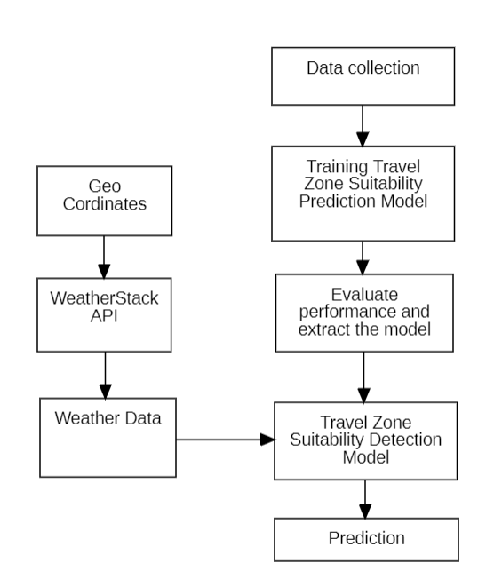 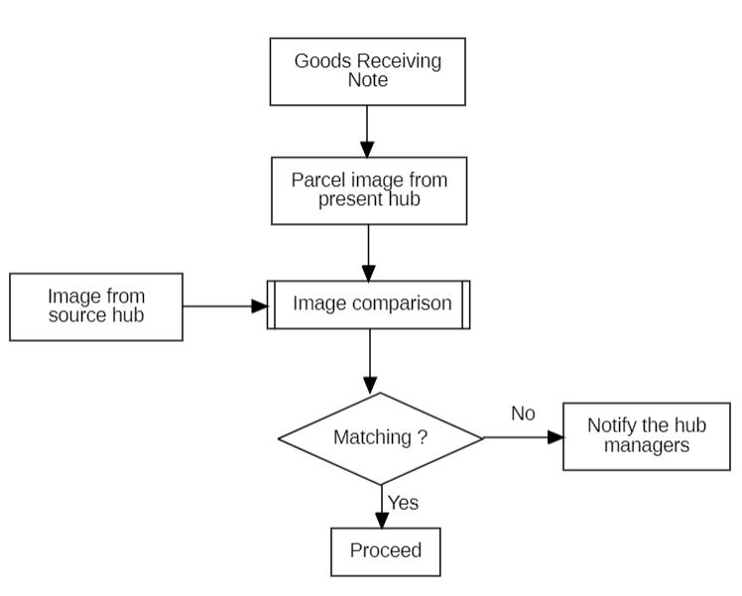

Fig 2. Destination Suitability for Safe Transport Fig 3. Parcel Verification

**Encrypted OTP QR Verification**

OTP Encrypted QR Verification is a security mechanism that involves the use of a one-time password (OTP) and encryption within a QR code for authentication purposes. This process typically includes generating a unique OTP, encrypting it, and embedding it into a QR code. Users can then scan the QR code to receive the encrypted OTP, which is decrypted for verification against the original OTP.

When the parcel received from the source hub, an OTP will be generated and encrypted using the MD5 cryptographic algorithm. The encrypted value will be converted into a QR code image stored with the name of the parcel code. For the receiving end the QR code will be accessible any time via their login. When the parcel requires delivery, on the receiving end the QR code is scanned through a open CV and read the QR code. Authentication for delivery is confirmed when the encrypted OTP value associated with the user matches the QR code value.

**Customer Sentiment Analysis**

Sentiment analysis plays a crucial role in logistics systems, contributing to the enhancement of user experience. Feedback data enables tasks such as scheduling, prioritizing, and more to be efficiently executed, ultimately leading to improved overall system performance and customer satisfaction. In this project a sentiment analysis model developed by using the Support vector machine (SVM) classification algorithm. The process of building the sentiment analysis model is given in the below figure 5.

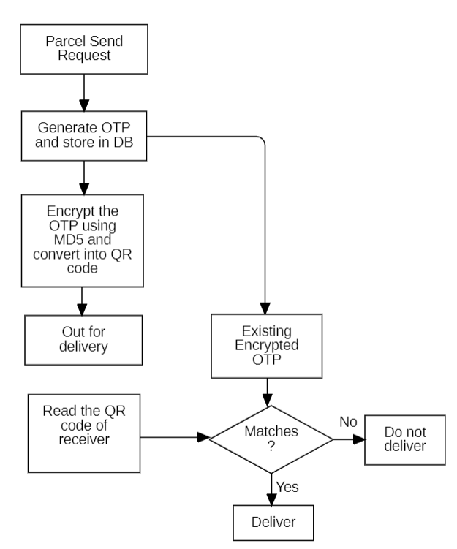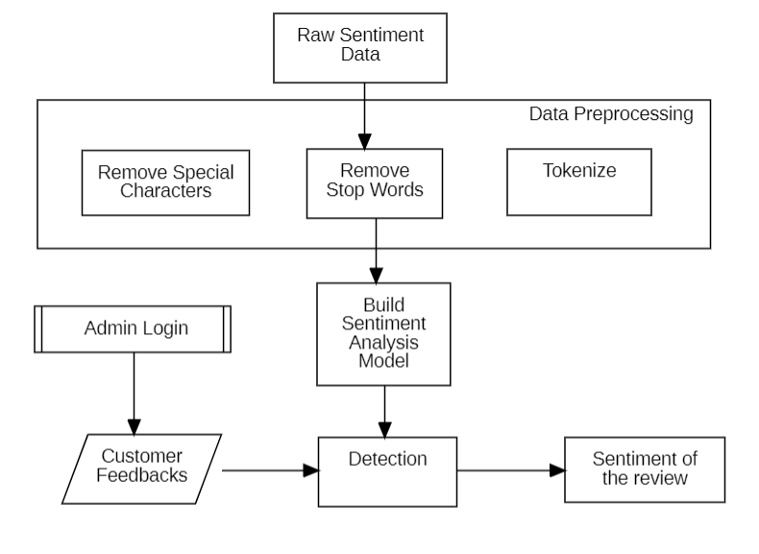

Fig 4. Encrypted OTP QR Verification Fig 5. Customer Sentiment Analysis

1. **RESULTS AND DISCUSSION**

This project has implemented in the windows environment with the 8 GB RAM specification. The machine learning models are trained using the Jupyter notebook and the Flask based backend implemented using the Spyder IDE. In order to achieve the different task various tech stacks used in this proposed project and that are listed below.

The MySQL database used for the data storing and retrieving mechanism. Open CV is a python library which plays the major role in the image processing. In this project Open CV used for QR code scanning and image similarity detection. In order to achieve the OTP encryption tasks, the MD5 algorithm utilized from the hashlib python library. The Multipurpose Internet Mail Extension (MIME) used for the mail notification services. GPS service us used for the geo coordinates. Weather stack open-source API service is utilized for get the weather data.

There are two machine learning models were utilized in this project. For the destination suitability prediction for safe transport, the gradient boosting algorithm were utilized. The Gradient boosting algorithm provided 90% of classification accuracy. For the customer feedback sentiment analysis, the Support Vector Machine (SVM) given 91% classification accuracy on predicting the type of sentiments. The both machine learning models are extracted as a pickle file and integrated within the system for the respective tasks. The system has strong login functionality for user authorization process and also there is a admin control to monitor the activities takes place in the application. The users are verified using the Email based OTP verification while joining. The system has tested with various test cases and different test data with the real time scenarios.

1. **CONCLUSION**

In summary, the importance of a luggage carrier system today lies in its ability to overcome challenges related to increased travel, globalization, security issues, and technological advancements. This project takes a comprehensive approach by integrating AI services into logistics management applications, addressing tasks like detecting similar parcels, estimating travel times, tracking upcoming hubs, and predicting destination suitability for safe travel. With GPS services, the system precisely identifies the luggage's location during transit, triggering alerts for any deviations.

To enhance security and counteract fraudulent activities, the project introduces an OTP-encoded QR code authentication mechanism, which improves upon traditional OTP methods. Additionally, incorporating sentiment analysis provides valuable insights from customer feedback and queries for ongoing system improvement. The project reduces manpower in parcel verification, routing, and tracking, while location-based transport zone comfortability detection simplifies travel in challenging areas. In conclusion, this project represents a significant step towards optimizing logistics processes, improving security measures, and adopting innovative technologies to create a more efficient and resilient luggage carrier system for the future.

**REFERENCES**

[1] Kalliopi Tsolaki, Thanasis Vafeiadis, Alexandros Nizamis, Dimosthenis Ioannidis and Dimitrios Tzovaras, Utilizing machine learning on freight transportation and logistics applications: A review, ICT Express 9, Elsevier, Volume 9, Issue 3, June 2023, https://doi.org/10.1016/j.icte.2022.02.001

[2] Terence, E. and Reddy, Siva and Reddy, K. Madhu and Reddy, T. Veera, Smart Luggage Carrier System, Proceedings of the International Conference on Innovative Computing & Communication (ICICC), May 27, 2022. Available at SSRN: https://ssrn.com/abstract=4121060 or http://dx.doi.org/10.2139/ssrn.4121060

[3] Tetsuya Manabe, Kazuo Mizuno, Keisuke Hatano and Masahiko Kaneko, "Ultraviolet sterilization information provision system of baggage carts and arriving baggage for airports", IATSS Research, December 2022. DOI:10.1016/j.iatssr.2022.12.004

[4] P. L. S. Krishnan, R. Valli, R. Priya and V. Pravinkumar, Smart Luggage Carrier system with Theft Prevention and Real Time TrackingUsing Nano Arduino structure, 2020 International Conference on System, Computation, Automation and Networking (ICSCAN), Pondicherry, India, 2020, pp. 1-5, doi: 10.1109/ICSCAN49426.2020.9262445.

[5] Afrin Khan, Bandini Nalwade, Neha Kharshinge3, Sonali Kamble, SMART LUGGAGE SYSTEM, International Research Journal of Engineering and Technology (IRJET), Volume: 06 Issue: 11, Nov 2019, https://www.irjet.net/archives/V6/i11/IRJET-V6I1130.pdf.

[6] Senthil, Sudha & Krishnamurthy, Brindha & R, Charanya. LUGGAGE TRACKING SYSTEM USING IOT. International Journal of Pure and Applied Mathematics. 117. 49-54. September2017.

[7] Deepti Mishra and Alok Mishra, "Improving Baggage Tracking, Security and Customer Services with RFID in the Airline Industry", Improving Baggage Tracking, Security and Customer Services with RFID in the Airline Industry, Vol. 7, No. 2, 2010.

[8] DeVries, Peter. The state of RFID for effective baggage tracking in the airline industry. IJMC. Volume6. 151-164. January 2008. 10.1504/IJMC.2008.016574.

[9] Valery Lukinskiy, Natalia Pletneva, Victor Gorshkov, Pyotr Druzhinin, "Application of the Logistics “Just in Time” Concept to Improve the Road Safety", Transportation Research Procedia, Volume 20, 2017, Pages 418-424

[10] Liu Y, Tao X, Li X, Colombo A and Hu S. Artificial Intelligence in Smart Logistics Cyber-Physical Systems: State-of-The-Arts and Potential Applications. IEEE Transactions on Industrial Cyber-Physical Systems. 10.1109/TICPS.2023.3283230.